Economic policy efficiency and recovery in an open economy
Jacques Mazier#, Luis Reyes*^ and Chin Yuan Chong*,
# Université Sorbonne Paris Nord and Chaire Energie et Prospérité
* Kedge Business School and Chaire Finance d’Impact
^ LASTA, University of Rouen Normandy
¹ Corresponding author
Abstract
We look at how the increased trade openness and correspondingly higher marginal propensity to import has resulted in weaker Keynesian multipliers, hence explaining the lower efficiency of economic policy in the context of economic openness. Using an empirical stock-flow consistent model for the French economy (SFC FR), we find that the fiscal multiplier is 1.3 in 1981 while it is only 0.8 in 2023. We then look at the macroeconomic impacts of the measures via a series of relevant shocks on public investment and confirm that the “globalization effect” plays a non-negligible role in explaining the weakening of macroeconomic policy efficiency. Last, we look at the implications of climate policy as detailed in the Pisani-Ferry & Mahfouz (2023) report to the French Prime Minister.
Keywords: Policy-mix, economic recovery, trade openness, empirical SFC models

JEL codes:

Introduction
The trade openness index is an indicator that is frequently used to measure the importance of international transactions relative to domestic transactions. It is defined as the sum of total imports and exports as percentage of GDP. The financial equivalent is measured by the sum of foreign assets and foreign liabilities in stocks as a percentage of GDP as proposed by Lane & Milesi-Ferretti (2003). The indicator uses stocks which reflect outstanding amount of international capital to reveal long-run trends instead of flows (Steiner & Saadma, 2016). But a ratio in flows (sum of the variations of foreign assets and liabilities in percentage of GDP) may also prove useful despite its higher volatility. Figure 1 shows the trade (left) and financial (right) openness indices in France from 1979 to 2021 (source: INSEE & Banque de France and authors’ calculations). The sum of total imports and exports (in volume at 2015 prices) increased from about 25% of the GDP in the 1980s to a peak of 65% in 2019 (x2.6). At current prices, the increase is more reduced, from 40% to 65% but still significant. Trade rose significantly between the 1980s and the 2000s, period after which it resumed rising at a more moderate pace. In 2020, the COVID-19 pandemic was responsible for a sharp 5% drop (comparable to the one observed during the Global Financial Crisis of 2008-2009). The growth of financial integration followed largely the same trend except during the Global Financial Crisis and COVID-19 pandemic. Financial openness (in stock) increased from 75% of GDP in the 1980s to 450% in 2019 (x6). In flows, the evolution is also on the rise from 10 to 55% of GDP in 2020 although more unstable with a drop after the financial crisis.
Figure 1: Trade openness (left) and financial openness (right) indices, 1979-2021.
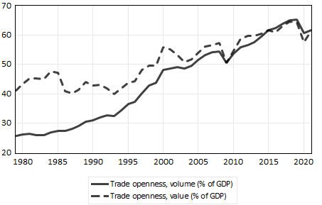 | 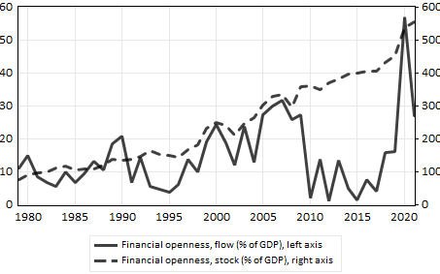
Source: INSEE & Banque de France and authors’ calculations

Much of the increase in imports has been driven by the rise in non-energy imports. Figure 2 shows total imports and the corresponding split into energy and non-energy imports as percentage of GDP in volume at 2015 prices (left) and in value (right) for France from 1979 to 2021. The volume of energy imports has been decreasing steadily since the 1980s and is barely at 2% of the GDP in 2021. This is partly due to the effort of energy saving undertaken since the oil shocks of the 1970s but also due to the build-up of nuclear power capacity in France. According to the International Atomic Energy Agency (IAEA), 52 new nuclear reactors were built between 1975 and 1990, adding almost 57GW to the French power grid. In current prices, the evolution is less pronounced. The increase of non-energy imports is more reduced due to the sharp decrease of the relative prices of imports ($p_{m}/p_{y}$), as it will be shown below. Conversely the decline of energy imports is smaller due to the revival of oil prices since the 2000s.

Figure 2: Total, non-energy and energy imports as % of GDP in volume at 2015 prices (left) and in value (right), 1979-2021.
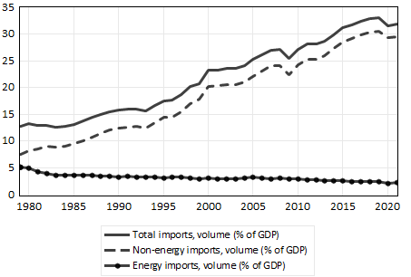 | 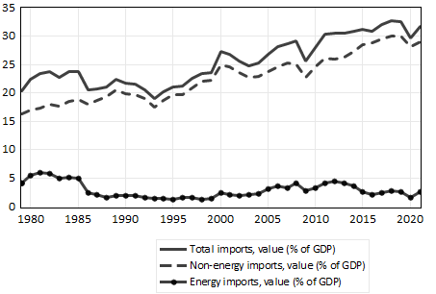
Source: INSEE and authors’ calculations

Given the strong increase in trade openness since the 1980s, it can be expected that the propensity to import has also increased, hence causing a significant leakage of stimulus going to imports. We look at how this has resulted in weaker Keynesian multipliers and hence the impact on the effectiveness of certain policies. More specifically, we look at the implications for climate policy as detailed in the report by Pisani-Ferry & Mahfouz (2023) to the French Prime Minister (PFM henceforth). Using an empirical stock-flow consistent model for the French economy (SFC FR), we analyze the macroeconomic impacts of these policies through a series of macroeconomic shocks.
The rest of the paper is organized as follows. We start with a brief discussion on the Keynesian multiplier and the marginal propensity to import in Section 2. Section 3 summarizes the overall structure of the model, highlighting the main equations relevant to the analysis at hand and the changes introduced compared to previous publications, especially regarding the modelling of foreign trade with a distinction between energy and non-energy imports. In Section 4, we look at the impact of trade openness of the French economy on its Keynesian multiplier through a simple public investment shock introduced in 1981 and in 2023. This is followed by a discussion of the impact of the implementation of the climate policy proposed in the PFM report in Section 5. Section 6 concludes.

Keynesian multipliers and the impact of the marginal propensity to import
The multiplier is a key concept in Keynesian theory that provides the basis for arguing for the implementation of activist policy aiming at full employment (Rochon & Gnos, 2008). A recent Post Keynesian study of the supermultiplier (a variant of the multiplier combining the latter with the accelerator) in the United States is carried out by De Lucchi (2024). The author analyses the differences in policy responses to the Global Financial Crisis and the Covid-19 pandemic and finds that the recovery from the latter took place faster than that of the former. Naturally, more ambitious public spending during lockdowns played a key role in these differences in recovery. Our work goes along the same lines for the French economy, and empirically contributes to the discussion on the importance of activist fiscal policy.
Spilimbergo et al. (2009) define the fiscal multiplier as the ratio of a change in output to an exogenous change in the fiscal position (a change in public spending or tax revenues) with respect to their respective baselines. The exogenous change is typically due to government intervention, through fiscal policies like tax cuts, public investment, etc. The multiplier is a common measure used to evaluate the macroeconomic impact of a fiscal policy as a high value of the multiplier implies a more significant impact of policy on the economy. The multiplier is greater than one given that increased government spending or tax cuts generate income which in turn induce spending. Using the simple Mundell-Fleming model, the multiplier for government spending can be expressed analytically as $1/{\left(1-mpc+mpm\right)}$ while the tax multiplier is ${-mpc}/{\left(1-mpc+mpm\right)}$ where $mpc$ is the marginal propensity to consume and $mpm$ the marginal propensity to import. In practice, many other factors can also affect the multipliers which are considered in more complex models used to estimate these. In a closed economy, $mpm=0$ and since $mpc$ is between 0 and 1, the government spending multiplier is greater than unity and higher than the tax multiplier.
However, the actual value of the multiplier is typically lower due to savings, imports and taxes which divert income from being spent on goods and services that are produced domestically (Charles et al, 2015). More specifically, Batini et al. (2014) listed six structural characteristics that could affect fiscal multipliers: trade openness, labor market rigidity, the size of automatic stabilizers, the exchange rate regime, the debt level, as well as public expenditure management and revenue administration. They also mention two conjunctural factors: state of the business cycle and the degree of monetary accommodation to fiscal shocks.
Fiscal multipliers are typically estimated using multi-variate time series models like vector autoregressive (VAR) models or macroeconomic models like structural ones or dynamic stochastic general equilibrium (DSGE). Based on a survey of 41 papers which use VAR or DSGE models for estimation, Mineshima et al. (2014) found that government spending multipliers are on average 0.75 and 0.25 for tax multipliers in advanced economies. Similarly, a study by the OECD (2009) showed that the average fiscal multiplier for public investment is 1.1 while that for tax cuts is between 0.3 and 0.5. While this is lower than expected, it is in line with Keynesian theory which holds that tax cuts are less effective than spending in stimulating the economy since the leakage to savings by households may be significant (due to the additional $mpc$ term in the above-mentioned Mundell-Fleming model).
Studies have also shown that the fiscal multipliers depend on the state of the economy, with higher multipliers during periods of recession compared to periods of high growth (Auerbach & Gorodnichenko, 2012). 10 to 30% of these variations can potentially be explained thanks to the concept of endogenous propensity to import where imports react strongly to economic levels, making it drop more than GDP in times of recession and making it rise when the business cycle is more favorable (Charles, 2016). Indeed, at the start of the European sovereign debt crisis, the International Monetary Fund (2010, fig. 3.2, pp. 99) estimated the effects of fiscal consolidation to be on average only 0.5 within two years based on data for 15 advanced economies from 1979 to 2009. However, austerity measures imposed on Greece, Italy, Portugal and Spain as a condition of an EU-IMF bailout resulted in much stronger contractionary effects than expected. Analysis done after the Global Financial Crisis by the IMF (Blanchard & Leigh, 2014) found that the actual fiscal multipliers were substantially higher than the one at the start of the crisis such that the multipliers implicit in the forecasts were too low by about one. The higher-than-normal multipliers could be explained by three factors: (1) low prevailing interest rates and a binding zero lower bound on the rates; (2) dependency of consumption and investment on current rather than future income and profits in the context of poorly functioning financial system coupled with lowered output; and (3) the high amount of slack in the economy.
In terms of the fiscal instruments, Batini et al (2014) found that for European Union countries, public investment has the highest multiplier (0.8) while public consumption has a lower impact (0.45). Tax cuts have multipliers of 0.2-0.5 depending on the type (consumption, corporate or labor). However, the impact of public consumption might be higher than that of public investment if the implementation delay of the latter (e.g. infrastructure) is long (Le Garrec & Touzé, 2021). Ilzetzki et al. (2013) did not find a significant difference between the multipliers for public investment and consumption based on their study of 44 developed and emerging countries from 1960-2007 while Boehm (2020) concluded that the public investment multiplier is smaller than the public consumption multiplier for short-lived shocks based on data of OECD countries from 2003-2016. Focusing on public investment, Deleidi et al. (2020) estimated the value of the fiscal multiplier to be near 1 for 11 Eurozone countries using data from 1970-2016.
Specifically for France, Creel et al. (2011) found that the first-year fiscal multipliers vary from 0.8 to 1.2 for tax cuts and from 1.0 to 1.3 for public spending based on the macroeconomic model e-mod.fr for France (Chauvin et al., 2002) using French data from 1980 to 2008. Focusing on the public investment multiplier, it varies from 1.2 (after 1 year), 0.7 (after 5 years) and 0.3 (after 10 years), assuming no output gap. Based on the Keynesian macroeconomic model Mésange (Allard-Prigent et al., 2002) which is developed and used by the French statistical office INSEE and the French Treasury and using data from 1980 to 2006, Klein & Simon (2010) found that the public investment multiplier varies from 1.12 after 1 year, increasing to its peak of 1.33 after 3 years before dropping to 1.03/0.74 after 5/10 years. These results are summarized in Table 1.
Table 1: Public spending/investment multipliers for France obtained using e-mode.fr/Mésange models
 | After 1 year | After 5 years | After 10 years
Public spending multiplier (e-mod.fr) | 1.2 | 0.7 | 0.3
Public investment multiplier (Mésange) | 1.12 | 1.03 | 0.74
Source: Creel et al. (2011) and Klein & Simon (2010)

Meanwhile, Biau & Girard (2005) found a short-term fiscal multiplier of 1.4, driven by induced private consumption and investment which, however, becomes insignificant in the medium term. These results are obtained with a structural VAR model on French data from 1978 to 2003. Using another structural VAR model on French data from 1980-2010, Cléaud et al. (2017) found that the public spending multiplier in France is around 1 on impact which then becomes statistically insignificant after about 3 years. Furthermore, when using a time-varying version of the model, they found no significant evolution of the multiplier over the entire period, which indicates that business cycle conditions have a limited influence on the multiplier. Using the EAGLE model developed by the ECB (Gomes et al., 2010), Kilponen et al. (2019) found that the first-year public spending multiplier for France to be similar for both temporary and permanent cuts (0.9). Similar results were obtained by Aldama et al. (2022) using a two-country model of the euro area (EA-BDF) which is based on the FR-BDF model of France (Lemoine et al., 2019) and a new block for the rest of the euro area.
Given the strong increase in trade openness since the 1980s, it can be expected that the propensity to import has increased accordingly and hence causing a significant leakage of stimulus going to imports. This is especially true if the stimulus is in the form of public investment as this requires significantly more imports as compared to public consumption (Bussière et al., 2013). Through a meta-analysis of 104 studies, Gechert (2015) estimated that 1 percentage point higher import-to-GDP ratio lowers the size of multiplier by 0.01 to 0.02. Using data of 120 countries over the period 1960-2014, Koh (2017) noted that countries with higher trade openness (defined as more than 60% of GDP) might not have smaller multiplier effect due to an offsetting increase in private consumption. However, this offsetting effect is unlikely to happen for highly indebted economies (debt-to-GDP exceeding 60%). Huidrom et al. (2020) used data from 34 developed and developing countries over the period 1980-2013 and found that high public debt dampens private consumption and hence results in lower fiscal multipliers. Several studies have also found lower or even negative fiscal multipliers in highly indebted economies (Ilzetzki et al, 2013; Auerbach & Gorodnichenko, 2013; Koh, 2017). This is partly due to concerns about debt sustainability and sovereign credit risk, resulting in increased borrowing cost which in turn reduces private domestic demand (Huidrom et al., 2020).

A stock-flow consistent econometric model for France
To understand the impact of trade openness on its Keynesian multiplier, we use a stock-flow consistent (SFC) econometric model for France (Mazier & Reyes, 2022; Mazier & Reyes, forthcoming; Mazier et al., forthcoming). SFC models are macroeconomic models that coherently integrate all stocks and flows of an economy where one sector’s expenditures correspond to another sector’s income, and all financial assets in one sector correspond to financial liabilities in another sector (Godley & Lavoie, 2012). They are based on a double-entry system of accounting where the flow of funds (income and expenditure) between sectors and resulting changes to the stocks of outstanding debt and financial assets are often represented in a transactions-flow matrix. These models also describe prices of goods and services, interest rates, asset prices and revaluation effects. These elements facilitate a complete analysis of the redistributive effects of prices, both on incomes and on assets and liabilities.
While the initial SFC models were theoretical (parameter values are not found from econometric estimation using actual economic data), there is a growing number of country-specific empirical SFC models (see Byrialsen et al., 2022 for a sample).

Model structure
The model presented here is an updated version of the one presented in Mazier et al. (forthcoming), which is compatible with Keynesian theory along the lines of Ferri & Minsky (2006). Its structure is analogous to that of already existing national-level SFC models. The economy is divided into five domestic agents: firms, households, banks, the central bank, the government, all of which interact with the rest of the world. The monetary and financial operations from the European Central Bank are included in the rest of the world.
The model is aggregate with a single product and is demand-led. Production in volume is determined by domestic and foreign demand (exports net of imports). Consumer prices depend on a mark-up pricing rule and are a function of unit labor costs and of import prices with an effect from demand pressures. Value added is split among the different agents depending on simple structural parameters. Its distribution between wages, profits and taxes is based on a wage-price-unemployment loop and on institutional relations to arrive at the balance of the agents’ accounts, that also considers their expenditures. Exports are analyzed at the level of all goods and services determined by demand and relative prices while imports are split into energy and non-energy products. Changes in the foreign trade block constitutes the core innovation of this model compared to the previous versions; the presentation of the equations below focuses mainly on these.
Financing methods via bank credit, bond and equity issuing, as well as financial investment behavior, are described for each agent. Changes in assets and liabilities, as well as investment and changes in inventories, combined with the revaluation accounts for capital gains or losses, allow for the transition of the accumulation accounts from one year to the next in an SFC manner.
With respect to non-financial assets (NFA), a distinction is made between produced capital (productive capital and housing), outstanding stocks and non-produced capital (mainly land). Among the financial assets, a split is made traditionally between F1 monetary gold and SDRs, F2 cash and deposits, F3 securities, F4 loans, F5 equity and investment fund shares, F6 insurance and pension funds, F7 financial derivatives and F8 other accounts receivable.
The closures of the model by main assets are important to explicit. They help understanding how the financing needs generated by economic policy are distributed among domestic and foreign agents. They are the following:
- Firms balance their accounts by issuing the necessary shares.
- Households balance their account by getting indebted with banks.
- Bank reserves balance the banks’ accounts.
- The equilibrium between assets and liabilities of the central bank corresponds to the missing equation of the model deducted from the writing of the other balances.
- Public debt, in the form of bank debt and bonds, balances the government’s account.
- Deposits on the liability side, as representative of foreign deposits held by domestic agents, adjust the rest of the world’s account.
- Banks absorb all public bonds available and provide credit without restriction.
- Banks balance the market of private domestic bonds and the market of domestic equities, the price of which depends on the price of foreign equity, which has a dominant effect.
- Foreign bonds and equity issued by the rest of the world equal their domestic demand.

Main equations

Foreign trade
Exports $\left(X\right)$ depend on foreign demand $\left(Y^{f}\right)$ as measured by total international trade in volume (world GDP in volume was used as the proxy previously) as well as the price competitiveness of exports $\left(\frac{p_{X}}{p_{X*}}\right)$ as given in Figure 3 (left). Exports are expressed in terms of a share of the international trade with a negative trend (-1%) reflecting a declining non-price competitiveness and a positive effect of export prices competitiveness (0.6). Export prices are determined in standard fashion with a price-maker arbitrage. French exports appear as being mainly price taker with an elasticity of export prices to export prices of the main competitors equal to 0.8. In this version, dependence on the ratio of exports from emerging countries over that from industrialized countries $\left(\frac{X_{emerg}}{X_{ind}}\right)$ has been added to the specifications. Increasing importance of exports from emerging markets tends to moderate the price of exports.
Exports, volume
$∆\ln\left(X\right)=0.8∆\ln{(Y^{f})}-0.3∆\ln\left(\frac{p_{X}}{p_{X*}}\right)-0.2\left(\ln\left(X_{-1}\right)-\ln\left(Y_{-1}^{f}\right)+2.3+0.6\ln\left(\frac{p_{X-1}}{p_{X*-1}}\right)+0.01t\right)$
1980-2021 (18.6) (-3.9) (-2.3) {-107.3} {-5.5} {-28.9}
(R2 = 0.91, DW = 1.7); {R2 = 0.97, DW = 1.6}
Price of exports
$$∆\ln\left(p_{X}\right)=-0.01+0.8∆\ln\left(p_{Y}\right)+0.4∆\ln\left(p_{X*}\right)-0.3\left(\ln\left(p_{X-1}\right)-0.1-0.8\ln\left(p_{X*-1}\right)-0.2\ln\left(p_{Y-1}\right)+0.1\left(\frac{X_{emerg-1}}{X_{ind-1}}\right)\right)$$
1981-2021 (4.1) (7.2) (5.4)
(-2.3) {7.6} {7.4} {7.4} {-2.8}
(R2 = 0.91, DW = 2.0); {R2 = 0.75, DW = 1.8}

Figure 3: Price competitiveness of exports $\left(\frac{p_{X}}{p_{X*}}\right)$ (left) and non-energy imports $\left(\frac{p_{Y}}{p_{{IM}_{ne}}}\right)$ (right), 1979-2021.
Ratio of domestic export prices to world export prices (2015 = 100)  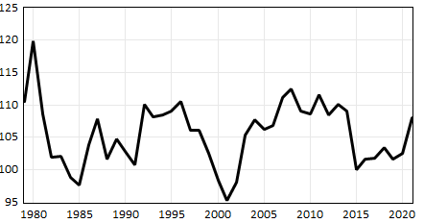 | Ratio of domestic prices to import prices  (2015 = 100)  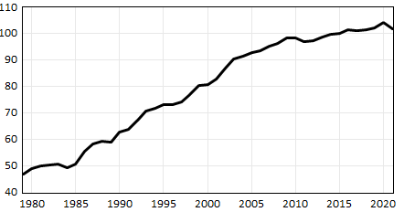

In this version, imports are separated into energy $\left({IM}_{e}\right)$ and non-energy $\left({IM}_{ne}\right)$. Energy imports in volume are proportional to GDP in volume with a decreasing trend reflecting the effort to save energy and the shift of the economy from industries to a service-based economy.
Non-energy imports in volume depend on domestic demand $\left(Y\right)$ as measured by GDP in volume. In the long-term equation, the relative volume of non-energy imports and GDP $\left(ln\left(\frac{{IM}_{ne}}{Y}\right)\right)$ can be described using the relative price effects between domestic and import prices $ln\left(\frac{p_{Y}}{p_{{IM}_{ne}}}\right)$ (see right graph in Figure 3). Import prices competitiveness $\left(\frac{p_{Y}}{p_{{IM}_{ne}}}\right),$ that is to say, competitiveness of domestic products against imports has been declining with a strong increase since the 1980s which has been a main driver of the penetration of the domestic market by imports. The opposition between export price competitiveness $\left(\frac{p_{X}}{p_{X*}}\right)$ and import price competitiveness $\left(\frac{p_{Y}}{p_{{IM}_{ne}}}\right)$deserves attention. The first one has been more or less stable in the long run with large fluctuations partly due to those of the dollar exchange rate. On the other hand, the second ratio has been permanently on the rise and has reflected a main feature of globalization that has led to a decline of the French productive system being unable to resist to the imports wave.
Another option is to use a more common expression to describe the propensity to import, in which case, the relative price effects could not be identified and only import prices $\left(p_{{IM}_{ne}}\right)$ could be isolated. This was the case for the total import volume equation in the previous version of the model (see below option 2). The total import volume $\left(IM\right)$ is then given by the sum of the two components.
Energy imports, volume
$$∆\left(\frac{{IM}_{e}}{Y}\right)=-0.6\left(\frac{{IM}_{e-1}}{Y_{-1}}-0.05+0.0004t\right)$$
1981-2021 (-9.8) {74.3} {-29.2}
(R2 = 0.76, DW = 2.2); {R2 = 0.97, DW = 1.9}
Non-energy imports, volume
Option 1: $∆\ln\left({IM}_{ne}\right)=2.0∆\ln\left(Y\right)-0.4∆\ln\left(\frac{p_{{IM}_{ne}}}{p_{Y}}\right)-0.6\left(ln\left(\frac{{IM}_{ne-1}}{Y_{-1}}\right)+2.4+0.8\ln\left(\frac{p_{{IM}_{ne-1}}}{p_{Y-1}}\right)-0.02t\right)$
1980-2021 (13.8) (-3.0) (-5.5) {-21.9} {-10.1} {10.0}
(R2 = 0.89, DW = 1.8); {R2 = 0.99, DW = 1.1}
Option 2: $∆\ln\left({IM}_{ne}\right)=2.4∆\ln\left(Y\right)-0.6\left(ln\left({IM}_{ne-1}\right)+11.5-2.2\ln\left(Y_{-1}\right)+0.1\ln\left(p_{{IM}_{ne}-1}\right)-0.01t\right)$
1981-2021 (17.3) (-4.1) {18.7} {23.8} {-2.3} {7.6}
(R2 = 0.84, DW = 1.9); {R2 = 0.99, DW = 1.3}
Total imports, volume
$$IM={IM}_{e}+{IM}_{ne}$$
Total imports, volume (previous version)
$$∆\ln\left(IM\right)=2∆\ln\left(Y\right)-0.5\left(\ln\left({IM}_{-1}\right)+9-1.9\ln\left(Y_{-1}\right)+0.2\ln\left(p_{IM-1}\right)-0.01t\right)$$
1980-2021 (18.1) (-4.9) {-13.2} {18.4} {-3.4} {5.3}
(R2 = 0.90, DW = 2.1); {R2 = 0.99, DW = 1.3}
The price of energy imports $\left(p_{{IM}_{e}}\right)$ depends mainly on the oil price $\left(p_{oil}\right)$ as it is, at least for now, the main component of energy imports. On the other hand, the price of non-energy imports $\left(p_{{IM}_{ne}}\right)$ depends on both domestic $\left(p_{Y}\right)$ and foreign prices $\left(p_{{IM}_{nc*}}\right)$. The total import price is then given by the total imports in value divided by the total imports in volume.
Price of energy imports
$$∆\ln\left(p_{{IM}_{e}}\right)=0.7∆ln\left(p_{oil}\right)-0.9\left(\ln\left(p_{{IM}_{e}-1}\right)+0.04-0.8\ln\left(p_{oil-1}\right)\right)$$
1981-2021 (26.1) (-7.8) {-3.6} {50.5}
(R2 = 0.96, DW = 2.0); {R2 = 0.99, DW = 2.0}
Price of non-energy imports
$$∆\ln\left(p_{{IM}_{ne}}\right)=0.6∆ln\left(p_{{IM}_{nc*}}\right)-0.3\left(\ln\left(p_{{IM}_{ne}-1}\right)-0.5-0.6\ln\left(p_{{IM}_{nc*}-1}\right)-0.2\ln\left(p_{Y-1}\right)+0.008t\right)$$
1981-2021 (14.3) (-3.3) {8.8} {7.6} {-2.2} {-7.7}
(R2 = 0.91, DW = 1.9); {R2 = 0.95, DW = 0.7}
Price of imports
$$p_{IM}=\frac{p_{{IM}_{ne}}{IM}_{ne}+p_{{IM}_{e}}{IM}_{e}}{IM}$$

Prices and wages
The price of household consumption $\left(p_{C}^{H}\right)$ is based in the medium term on a mark-up from unit labor cost with the effect of import prices. In the short term the inflation rate $\left(Δ\ln{(p_{C}^{H})}\right)$ is determined by the growth rate of unit labor costs $\left(Δ\ln{(ULC)}\right)$ with a short-term effect on demand pressure, measured by the output-to-capital ratio $\left(\frac{va^{M}}{K_{1}^{M}}\right)$. The growth rate of import prices $\left(Δ\ln{(p_{IM})}\right)$ has also been added in the short- and medium-terms. Last, a lagged effect of the taxes on production (net of subsidies received) in percentage of GDP $\left(\frac{T_{P-1}-Sub_{-1}}{p_{Y-1}Y_{-1}}\right)$ has been introduced in the short term.
Household consumption deflator
$∆\ln\left(p_{C}^{H}\right)=-0.1+0.4∆\ln\left(p_{C-1}^{H}\right)+0.1∆\ln\left({ULC}^{M}\right)+0.2∆\ln\left({ULC}_{-1}^{M}\right)+0.1∆\ln\left(p_{IM}\right)+0.2\left(\frac{va^{M}}{K_{1}^{M}}\right)+0.3\left(\frac{T_{P-1}-Sub_{-1}}{p_{Y-1}Y_{-1}}\right)-0.1\left(\ln\left(p_{C-1}^{H}\right)-0.3-0.9\ln\left({ULC}_{-1}^{M}\right)-0.1\ln\left(p_{IM-1}\right)\right)$
Wage per worker in the market sector $\left(w^{M}\right)$ results from a wage-price-unemployment relation with an indexation slightly less than unity, a medium-term labour productivity $\left(\frac{{va}^{M}}{N^{M}}\right)$ effect and a short-term effect of the rate of unemployment $\left(u\right)$. This wage per worker in the market sector serves as a reference for the evolution of that of the other institutional sectors.
Wage per worker in the market sector
$∆\ln\left(w^{M}\right)=-0.09+0.9∆\ln\left(p_{C}^{H}\right)+0.5∆\ln\left(\frac{{va}^{M}}{N^{M}}\right)-0.04\ln\left(u\right)-0.2\left(\ln\left(w_{-1}^{M}\right)+1.5-0.7\ln\left(p_{C-1}^{H}\right)-1.1\ln\left(\frac{{va}_{-1}^{M}}{N_{-1}^{M}}\right)\right)$
The wage bill for the market sector $\left(W^{M}\right)$ is given by the product of salaried employment $\left(N^{S_{M}}\right)$ and wage per worker. Salaried employment is derived from total employment in the market sector through a trend evolution. Unit labor costs of the market sector $\left({ULC}^{M}\right)$ is one of the main factors determining consumer prices and is given by the sum of the total wage bill $\left(W^{M}\right)$, labour contributions $\left({LC}^{M}\right)$ and labor tax paid by the employers $\left(T_{L_{p}}^{M}\right)$ as well as the labor contributions paid by the workers $\left({LCW}_{p}^{H_{M}}\right)$; divided by the total value added of the market sector in volume $\left({va}^{M}\right)$.
Wage bill, market sector
$$W^{M} = w^{M}{(N}^{S_{M}})$$
Salaried employment, market sector
$$\ln\left(\frac{N^{S_{M}}}{N^{M}}\right)=1.2+0.7\ln\left(\frac{N_{-1}^{S_{M}}}{N_{-1}^{M}}\right)+0.0015t-0.002t_{2000-2021}$$
Unit labour cost, market sector
$${ULC}^{M}=\left(\frac{W^{M}+{LC}^{M}+{LCW}_{p}^{H_{M}}+T_{L_{p}}^{M}}{{va}^{M}}\right)$$

Employment
Employment in the market sector $\left(N^{M}\right)$ adjusts with respect to medium-term employment resulting from a simple determination of labour productivity $\left(\ln\left(\frac{{va}^{M}}{N^{M}}\right)\right)$based on a simple Cobb-Douglas function. This relation with an elasticity of 0.2 related to the capital per head and a declining trend of technical progress is used to determine the “desired” employment in the employment equation.
Labor productivity, market sector
$$\ln\left(\frac{{va}^{M}}{N^{M}}\right)=0.2\ln\left(\frac{K_{1}^{M}}{N^{M}}\right)+0.02t-0.01t_{1992}-0.007t_{2008}+2.1$$
Employment, market sector
$∆\ln\left(N^{M}\right)=0.2Δ\ln\left(N_{-1}^{M}\right)+0.5Δ\ln\left({va}^{M}\right)-0.4\left(\ln\left(N_{-1}^{M}\right)+\frac{\left[0.2\ln\left(K_{1-1}^{M}\right)+0.02t-0.01t_{1992}-0.007t_{2008}+2.1-\ln\left({va}_{-1}^{M}\right)\right]}{(1-0.2)}\right)$
Public employment $\left(N^{G}\right)$ is exogenous and total employment $\left(N\right)$ is the sum of employment in the market sector and in the public sector. Active population $\left(AP\right)$ i.e. labor force results from a flexion of the activity rate $\left(\frac{AP}{TAP}\right)$ as a function of job creation, $\left(TAP\right)$ being the working age population. Finally, the unemployment rate $\left(u\right)$ is given by the ratio of the number of unemployed ($U$, given by $AP-N$) to the active population.
Active population
$∆\ln{(AP)}=0.5∆\ln\left(N\right)+0.5∆\ln\left(TAP\right)-0.3\left(\ln{({AP}_{-1})}+0.5\ln\left(N_{-1}\right)+0.4\ln\left({TAP}_{-1}\right)+0.002t\right)$
Unemployment rate
$u=\left(\frac{U}{AP}\right)$

Basic shock on public investment
In this section, we first look at the results from a basic shock on public investments. In Figure 1, we saw that trade openness has increased significantly from 1979 to 2021. To understand how this has impacted the public investment multiplier and hence the effectiveness of fiscal policy under a Keynesian framework (Palley, 2013), we apply a basic permanent shock of 1% of GDP in public investment starting in 1981 and 2023, respectively. Three slightly different models are considered here, and they are described in Table 2. Model 1 corresponds to the previous version of the model. Model 2 incorporates a separation between energy and non-energy imports with an explicit effect of the import prices competitiveness. Model 3 keeps this separation between energy and non-energy imports but without the import price competitiveness effect, as it was the case in Model 1.Table 2: Description of models used
 | Description
Model 1 | - No separation of imports into energy and non-energy imports  - Imports volume is given by:  $$∆\ln\left(IM\right)=2∆\ln\left(Y\right)-0.5\left(\ln\left({IM}_{-1}\right)+9-1.9\ln\left(Y_{-1}\right)+0.2\ln\left(p_{IM-1}\right)-0.01t\right)$$
Model 2 | - Separation of imports into energy and non-energy imports  - Non-energy imports volume is given by:  $∆\ln\left({IM}_{ne}\right)=2.0∆\ln\left(Y\right)-0.4∆\ln\left(\frac{p_{{IM}_{ne}}}{p_{Y}}\right)-0.6\left(ln\left(\frac{{IM}_{ne-1}}{Y_{-1}}\right)+2.4+0.8\ln\left(\frac{p_{{IM}_{ne-1}}}{p_{Y-1}}\right)-0.02t\right)$
Model 3 | - Separation of imports into energy and non-energy imports  - Non-energy imports volume is given by:  $$∆\ln\left({IM}_{ne}\right)=2.4∆\ln\left(Y\right)-0.6\left(ln\left({IM}_{ne-1}\right)+11.5-2.2\ln\left(Y_{-1}\right)+0.1\ln\left(p_{{IM}_{ne}-1}\right)-0.01t\right)$$
Figure 4 shows the changes to the various components of GDP (in volume) after a permanent basic shock of about 1% of GDP in public investment starting in 1981 (left) or 2023 (right) for the 3 models mentioned above. Note that the level of the shock is set at 1% of GDP in 1981 or 2021 (last data point in our database) and does not change in the simulations, hence the shock becomes less than 1% as time goes by. Adjusting for this variation, the values of the public investment multiplier on impact, after 5 years and after 10 years as given by the different models are summarized in Table 3. These values are in line with the values obtained by Creel et al. (2011) and Klein & Simon (2010) as summarized in Table 1. For model 1, the total import-to-GDP ratio increases by 21.4 percentage points from 1981 to 2023 while the multiplier decreases by 0.43. The drop in the multiplier is hence 0.43/21.4 = 0.02 per percentage point increase in import-to-GDP ratio. The corresponding values for models 2 and 3 are 0.025 and 0.023, respectively. These values are in line with the results obtained by Gechert (2015) who estimated such drop in the range of 0.01-0.02.
Table 3: Public investment multipliers given by the different models
 | 1981 (impact) | 1986 (after 5 years) | 1991 (after 10 years)
Model 1 | 1.38 | 0.98 | 0.44
Model 2 | 1.50 | 0.79 | -0.31
Model 3 | 1.36 | 0.93 | 0.28
 | 2023 (impact) | 2028 (after 5 years) | 2033 (after 10 years)
Model 1 | 0.95 | 0.79 | 0.50
Model 2 | 1.00 | 0.51 | -0.34
Model 3 | 0.88 | 0.69 | 0.33
Source: authors’ calculation
The main difference lies in the increased imports in recent years as compared to those of the early 1980s. Taking a closer look at the long-term equation for the non-energy imports for model 3, we have:
$$ln\left({IM}_{ne}\right)=-11.5+2.2\ln\left(Y\right)-0.1\ln\left(p_{{IM}_{ne}}\right)+0.01t$$
In order to isolate the increase in imports due to the investment shock, we compare it to the reference path (r) and assuming constant $p_{{IM}_{ne}}$:
$$\ln\left(\frac{{IM}_{ne}}{{IM}_{ne}^{r}}\right)=2.2\ln\left(\frac{Y}{Y^{r}}\right)$$
$$\ln\left(1+\frac{∆{IM}_{ne}^{trend}}{{IM}_{ne}^{r}}\right)=2.2\ln\left(1+\frac{∆Y^{trend}}{Y^{r}}\right)$$
By linearizing the trend supplement to imports using the first term in the Taylor series expansion, we get
$$\frac{∆{IM}_{ne}^{trend}}{{IM}_{ne}^{r}}=2.2\frac{∆Y^{trend}}{Y^{r}}$$
$$∆{IM}_{ne}^{trend}=2.2\left(\frac{{IM}_{ne}^{r}}{Y^{r}}\right)∆Y^{trend}$$
This gives a marginal propensity to import in physical terms (Shinohara, 1957) for non-energy imports of 2.2*0.086=0.19 in 1981 and 2.2*0.31=0.69 in 2023 (considering model 3). Using the same approach, the marginal propensity to consume is found to be relatively stable at 0.84*0.54=0.45 in 1981 and 0.84*0.53=0.44 in 2023. Using these numbers and the expression of government spending multiplier (since public investment is part of government spending) given by Mundell-Fleming model $1/{\left(1-mpc+mpm\right)}$, we obtain a multiplier of 1.35 in 1981 and 0.80 in 2023 for model 3 which is close to the values given in Table 3. The multipliers obtained using the same approach for all 3 models are summarized in Table 4.
Table 4: Summary of marginal propensity to consume and import and the resulting government spending multiplier
For 1981 | Marginal propensity to consume | Marginal propensity to import | Multiplier
Model 1 | 0.45 | 0.25 | 1.25
Model 2 | 0.45 | 0.085 | 1.57
Model 3 | 0.45 | 0.19 | 1.35
For 2023 | Marginal propensity to consume | Marginal propensity to import | Multiplier
Model 1 | 0.44 | 0.68 | 0.81
Model 2 | 0.44 | 0.30 | 1.16
Model 3 | 0.44 | 0.69 | 0.80
Source: authors’ calculation
A more detailed decomposition of the multipliers and of their dynamics is given in Figure 4. It illustrates the higher value of the multipliers in the 1980s compared to those of the 2020s. In all cases the leakage through imports is the main explaining factor. The more important impact of the declining exports in the 2020s due to the loss of competitiveness and to the larger weight of exports is the second factor. Models 1 (without a split energy/non-energy) and 3 (with a split but without price competitiveness effect) give rather close results. Model 2 is more specific with a higher multiplier effect in the short-term both in the 1980s and in the 2020s but this multiplier effect declines more rapidly and becomes slightly negative after ten years. This is due to the increase of imports linked to the rising prices and the loss of competitiveness. Furthermore, the higher inflation induces a loss of purchasing power and a decline of households’ real wealth which also reduce consumption and real activity. The recovery the medium-long term is due to the decline in prices (see below) which boosts real income and households’ real wealth, as well as price competitiveness.
Figure 4: Changes to the various components of the GDP (volume) after a basic shock of 1% of GDP in public investment starting in 1981 (left) and in 2023 (right).
Shock in 1981 | Shock in 2023
Model 1  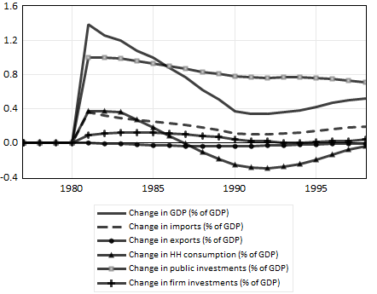 | Model 1  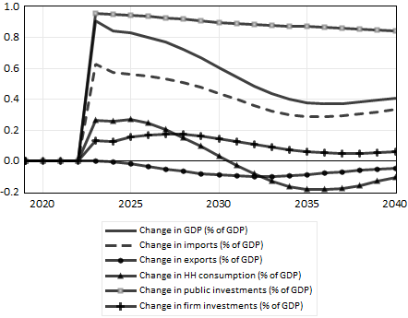
Model 2  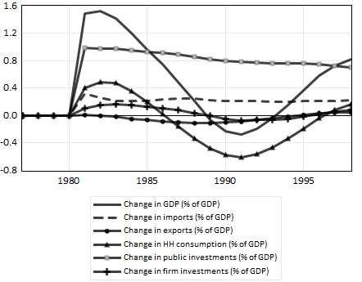 | Model 2  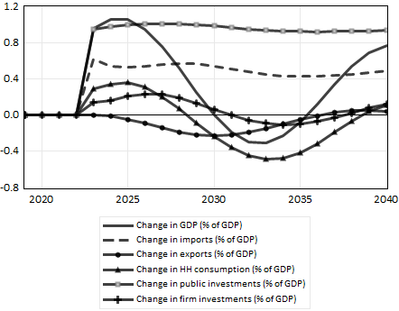
Model 3  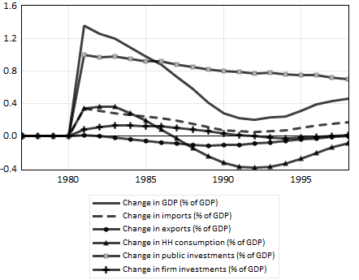 | Model 3  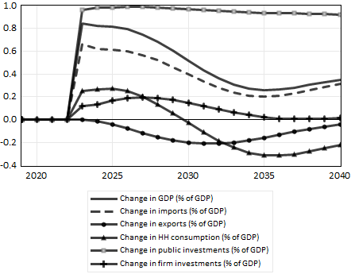
The other results of this shock on public investment are rather unsurprising (Figure 5). With the increasing activity prices rise, more in the 1980s than in the 2020s, but this price slippage remains moderate, and a reversal appears in the medium-term, which is in line with the declining activity. The trade balance deteriorates in the short-term but recovers progressively thanks to the declining activity and price stability. The worsening is more pronounced in the medium-term during the 2020s than during the 1980s due to greater trade openness, especially in model 2, where the effect of the competitiveness loss is more sensitive. Consequently, the financing capacity of the rest of the world improves more durably in model 2. The deterioration of the public balance in the short-term is more pronounced in the 2020s than in the 1980s. After a short-lived improvement induced by the recovery, the worsening of the public balance becomes more durable due to a permanent increase of public expenditures combined with a declining recovery, the deterioration being more marked in the case of model 2. Government debt in % of GDP increases progressively in the long-term.
The contrasted evolution of government debt in the 1980s and 2020s in Figure 5 deserves attention. French public debt is around 20% of GDP in the early 1980s, so that a 1% of GDP increase in public investment financed via debt will increase the latter by $\frac{1\%}{0.2}=5\%$. However, in the 2020s public debt is at around 120% of GDP, so that a 1% of GDP increase in debt-financed investment raises public debt by $\frac{1\%}{1.2}=0.83\%$. Accordingly, the government debt increase in the 2020s is more limited than that of the 1980s because of this level effect, at least in the first decade after the shock is performed. In both cases, demand-led growth driven by public debt is sustainable (Aspromourgos, 2014).
Overall, the multiplier effect of public investment subsists but is smaller in the 2020s due to the larger trade openness and the penetration of the domestic market by imports. The trade balance and public balance worsen in the short and medium term. In this context, it is interesting to evaluate the effects of climate action engaged by the French government.
Figure 5: Basic shock of 1% of GDP in public investment starting in 1981 (left) and in 2023 (right). The solid, dotted, solid with circles lines represent models 1-3, respectively.
Shock in 1981 | Shock in 2023
Real GDP ⁽¹⁾  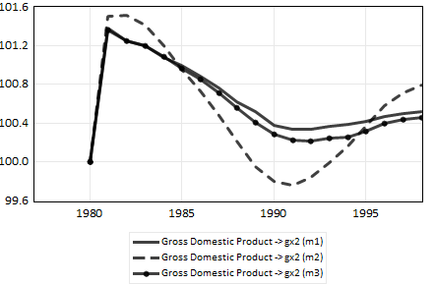 | Real GDP ⁽¹⁾  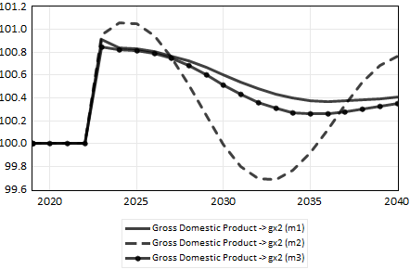
Consumer prices ⁽¹⁾  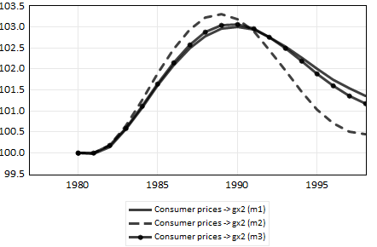 | Consumer prices ⁽¹⁾  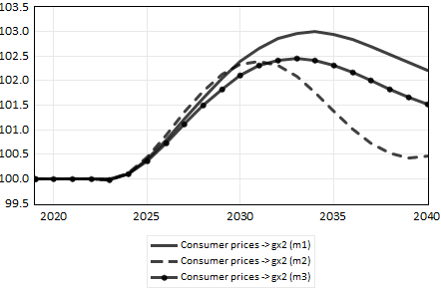
Real wage per worker ⁽¹⁾  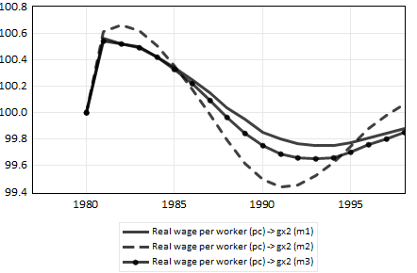 | Real wage per worker ⁽¹⁾  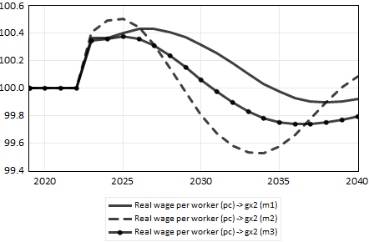
Real households’ wealth ⁽¹⁾  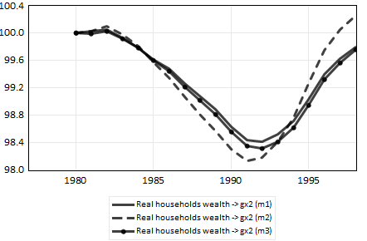 | Real households’ wealth ⁽¹⁾  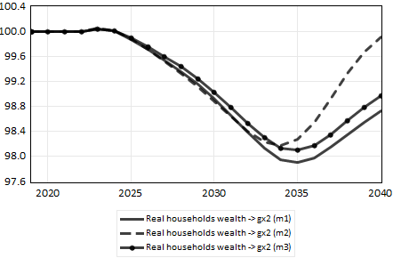
Firms’ accumulation rate (%) ⁽²⁾  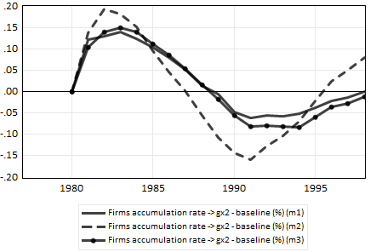 | Firms’ accumulation rate (%) ⁽²⁾  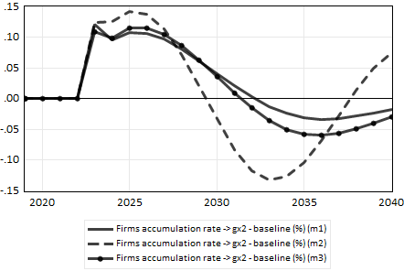
Trade balance (% of GDP) ⁽³⁾  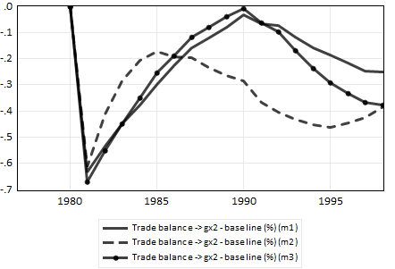 | Trade balance (% of GDP) ⁽³⁾  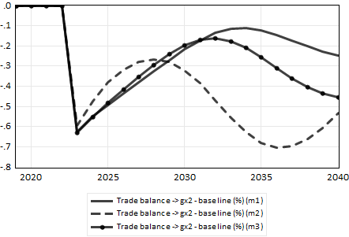
Public balance (% of GDP) ⁽³⁾  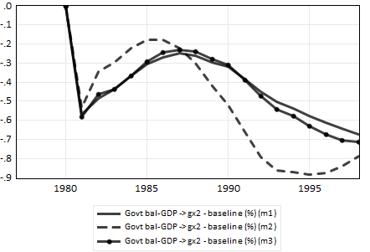 | Public balance (% of GDP) ⁽³⁾  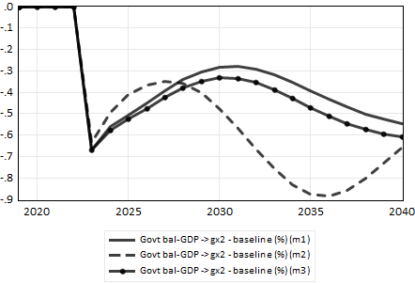
Government debt (% of GDP) ⁽³⁾  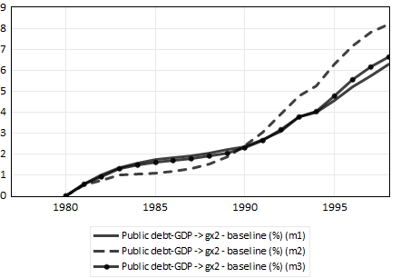 | Government debt (% of GDP) ⁽³⁾  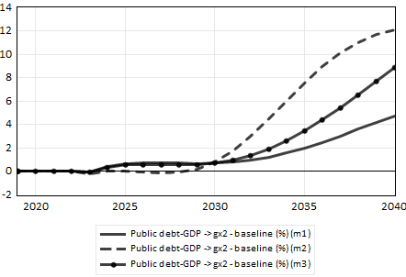
Financing capacity of ROW (% of GDP) ⁽³⁾  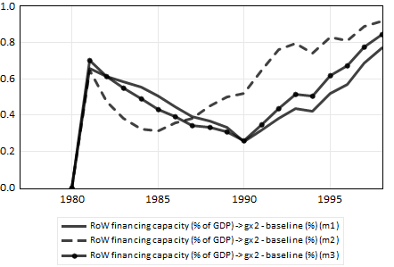 | Financing capacity of ROW (% of GDP) ⁽³⁾  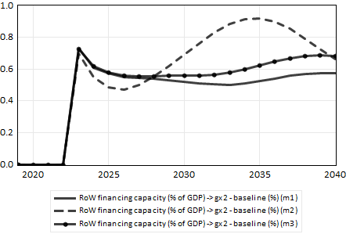
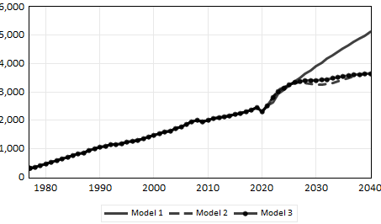
- Presented as the after-shock series multiplied by 100, divided by the baseline series.
- Presented as the after-shock–baseline difference, with the baseline and after-shock series in %.
- Presented as the after-shock–baseline difference, with the baseline and after-shock series in % of GDP.

Effects of Pisani Ferry-Mahfouz program
Thanks to a rather large mobilization of the economic administration, an assessment of the main economic problems raised in France with respect to climate action has led to the publication of an important report to the Prime Minister (the Pisani Ferry-Mahfouz report, PFM henceforth). This detailed document highlights the importance of the industrial revolution implied by the climate transition and the specific role played by the public sector. The large investment effort is estimated at a detailed level with the implication of the various actors concerned. The report evaluates the macroeconomic impact and the consequences for public finance. Although it recognizes the high degree of uncertainty that prevails, the report emphasizes the need for an increasing public debt combined with a temporary rise in taxes on the wealthiest. It also mentions the risk of inflationary pressures in the medium-term. The methodology used relies mainly on a detailed bottom-up analysis and the use of a rather disaggregated macroeconomic model to evaluate detailed policies such as assistance with thermal insulation work or investment in new electric power stations. However, the macroeconomic synthesis of the impact of all the measures is not fully achieved.
The investment programs of firms, households and the government induced by climate action in France by 2030-2040 with the financial contribution of the public sector as given by PFM have been introduced in the previous version of SFC FR to evaluate the ex-post effects of this rather large shock (Chong et al. (2024). Table 5 recaps the main characteristics of this aggregated version of the PFM program.
Table 5: The PFM program in an aggregated version
In bn€ 2030 per year | Additional investment in value | Public financing
Public investments | 14
Households investments | 21 | 14 (social transfers)
Firms investments | 40 | 3 (subsidies)
Total | 75 | 31
In bn€ 2023 per year | Additional investment in value | Public financing
Public investments | 14/1.2 = 11.7
Households investments | 21/1.2 = 17.5 | 14/1.2 = 11.7  (social transfers)
Firms investments | 40/1.2 = 33.3 | 3/1.2 = 2.5 (subsidies)
Total | 75/1.2 = 62.5 | 31/1.2 = 25.8
Values at 2023 prices (1.2 is the value of the price index in 2030, base 2023)
Source: Chong et al. (forthcoming)
To this we must add a special treatment of automobile purchases by households in the PFM report. It is assumed that households will buy more electric cars (with public support estimated at €2 billion a year) but will buy fewer cars overall (due to changes in mobility patterns, etc.). A reduction in household consumption of €8 bn per year is therefore assumed. Some adjustments are also made to incorporate the specificities of some shocks linked to the climate transition. A correction of 0.5 percentage point is applied to the import growth rate as a significant proportion of the new investments linked to the climate transition will have to be imported. With the separation of energy and non-energy imports in the new model, the same correction is now applied to the non-energy imports due to the nature of the climate-related investments. Last, we also suppose that the additional investment to renovate or develop renewable energies will have no positive impact on labor productivity, which leads to the introduction of a negative variation variable on the productivity rate of growth (-0.16% per year).
Figure 6 shows the main effects of the PFM program in relation to the baseline path using three versions of the model, the previous one (model 1) and the two versions presented in the previous sections with a separation of imports in energy and non-energy imports (model 2 with import prices competitiveness effects and model 3 with only import price effects). The previous version of the model and model 3 provide rather close results. Some differences appear with model 2.
Despite the downsizing of the multiplier effect seen in the previous section, the low carbon transition program results in a sustained recovery. However, it gradually erodes and does not persist in the long term in the case of model 2 (see panel in the left column of Figure 6). This is due to the increase in consumer prices which deteriorates price competitiveness and induces rising imports. Prices gradually return to their reference path during the 2030s and even below in case of model 2, inducing a new revival thanks to a rising purchasing power. The public balance improves (0.4% of GDP at medium term) thanks to rising GDP volume and prices and in spite of the increasing public expenditures. When taking into account the price effects on imports (model 2) this improvement of public finance does not last and appears more fluctuating in line with economic activity. The financing capacity of firms worsens steadily (-1.2% of GDP) as does that of households (-0.5% of GDP). The most worrying counterpart is the deterioration of the current account and of the domestic financing capacity (-1.2% of GDP in the medium-term) with limited improvement in the long-run. The evolution is of the same nature, although worse, in the case of model 2.
In terms of financial assets and liabilities, public debt falls significantly in the medium-term (around -6% of GDP) thanks to the improvement in the public balance. This does not last in the case of models 2 and 3 since public debt in % of GDP returns to its reference value. Households’ debt increases significantly in all cases. On the corporates’ side net equities issuance grows sharply in line with the declining profit rate. Firms’ financial wealth worsens structurally in all cases (-20% of GDP) as does that of households. The rest of the world increasingly becomes a creditor for France in all the versions of the model used. More than a problem of public debt, the financing of the climate transition program in France raises difficulties for the other domestic agents and this leads to an increasing external dependency which may be hardly sustainable. However, it must be recalled that the climate transition program will not be implemented in one country at the time. The rest of the world will also face these or similar challenges. Taking into account this possible reaction of the rest of the world could counter the constraints highlighted in the previous simulations.
An alternative scenario (panels on the right column of Figure 6) can be considered where firms preserve their profits to a greater extent after 2030 at the cost of a more pronounced inflation rate (0.5% per year after 2030). In this perspective prices continue to rise, real wages decline allowing a restoration of the profit share. With the fall of real income, growth weakens. Depending on whether the import price competitiveness effect is taken into account or not, the impact of this inflationary drift is more or less unfavorable for the trade and public balances. Instead of declining, public debt in % of GDP would return to its reference level of the baseline. Beyond these differences, the conclusions drawn from the previous scenarios would not be deeply affected.
Figure 6: Effects of PFM program (PFM reference, left; PFM reference with additional inflation from 2030, right) according to SFC FR (previous model used in Chong et al. (forthcoming) in solid line and using models 2 & 3 described in Table 2 in dotted line and solid line with circles, respectively).
PFM reference | PFM reference with additional inflation from 2030
Real GDP ⁽¹⁾  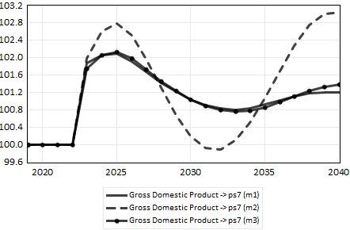 | Real GDP ⁽¹⁾  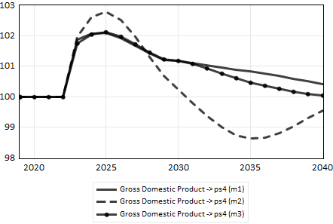
Consumer prices ⁽¹⁾  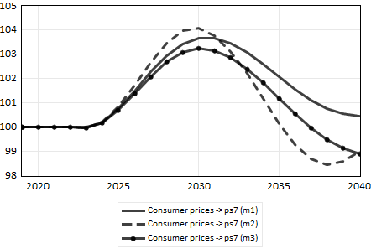 | Consumer prices ⁽¹⁾  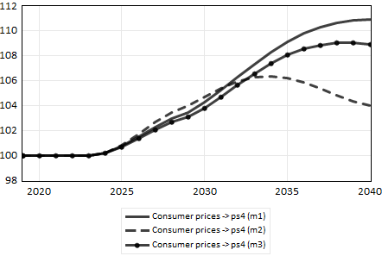
Real wage per worker ⁽¹⁾  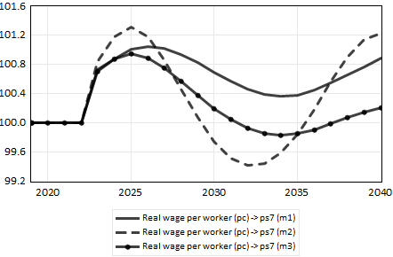 | Real wage per worker ⁽¹⁾  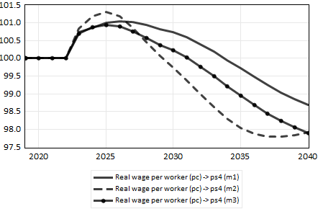
Real households’ wealth ⁽¹⁾  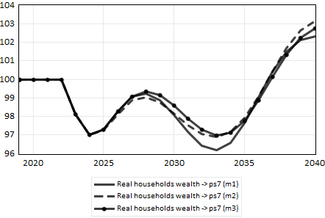 | Real households’ wealth ⁽¹⁾  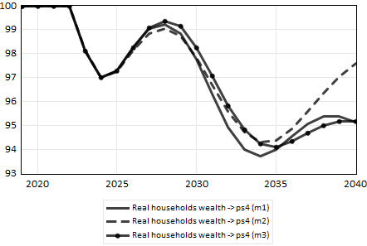
Firms’ accumulation rate (%) ⁽²⁾  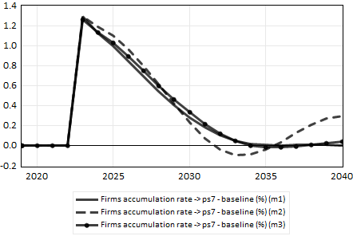 | Firms’ accumulation rate (%) ⁽²⁾  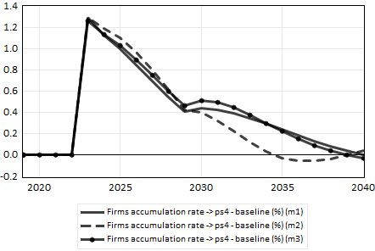
Trade balance (% of GDP) ⁽³⁾  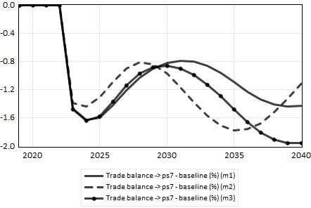 | Trade balance (% of GDP) ⁽³⁾  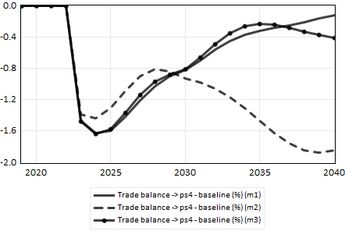
Public balance (% of GDP) ⁽³⁾  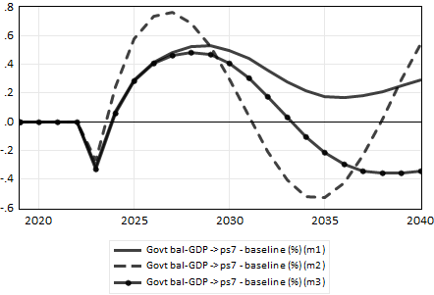 | Public balance (% of GDP) ⁽³⁾  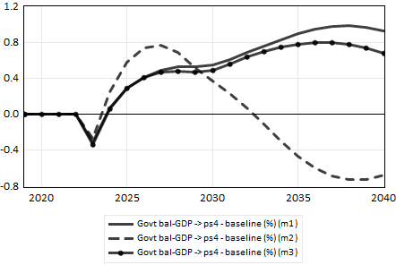
Government debt (% of GDP) ⁽³⁾  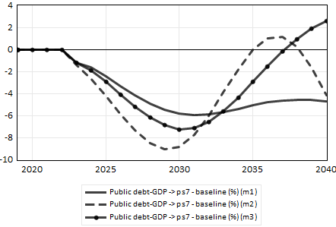 | Government debt (% of GDP) ⁽³⁾  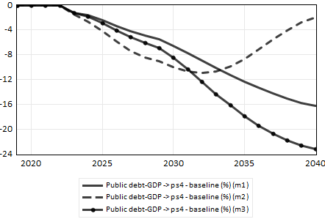
Financing capacity for Rest of the World (% of GDP) ⁽³⁾  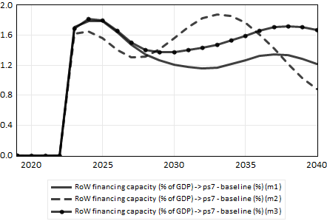 | Financing capacity for Rest of the World (% of GDP) ⁽³⁾  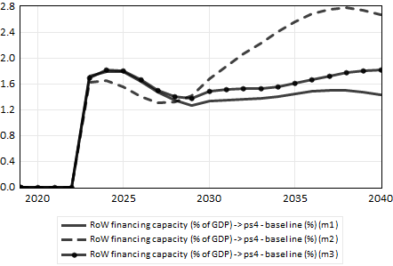
- Presented as the after-shock series multiplied by 100, divided by the baseline series.
- Presented as the after-shock–baseline difference, with the baseline and after-shock series in %.
- Presented as the after-shock–baseline difference, with the baseline and after-shock series in % of GDP.

Conclusion
This paper examined how the increased trade openness and correspondingly higher marginal propensity to import has weakened the traditional Keynesian multiplier and, hence, the efficiency of economic policy in the context of trade and financial openness. We used a new version of an SFC empirical model for France (SFC FR) in which we introduced a distinction between energy and non-energy imports. Foreign trade equations have been improved. They have highlighted a significant negative trend for non-price competitiveness and a significant effect of price competitiveness, both for exports and imports. It appeared that export price competitiveness has been stable in the long-run with large fluctuations, mainly due to the dollar exchange rate, while import price competitiveness has been on a declining path since the 1980s and has been one of the main drivers of the penetration of the domestic market. Using SFC FR we found that with the increasing trade openness the fiscal multiplier declined since the 1980s, going from 1.3 in 1981 to 0.8 in 2023. Last, the macroeconomic impact of the climate transition program proposed by the PFM report has been evaluated with different versions of the model. Despite the reduced multiplier effect the climate transition program has a positive impact on the economic activity which progressively erodes. After an initial inflationary drift, prices return to their baseline. The public balance improves but the financial capacity of firms and households worsen. More than a problem of public debt as mentioned in the PFM report, the more worrying counterpart is the worsening of the domestic financial capacity and the increasing external dependency. However, it must be recalled that the rest of the world will also have to adjust to face the climate transition which could mitigate the constraints.

Acknowledgments
Jacques Mazier acknowledges the support of the Chair Energy and Prosperity, under the aegis of La Fondation du Risque. Luis Reyes and Chin Yuan Chong acknowledge the support of the Chair LCL-Kedge Impact Finance.

References
Aldama, P., Gaulier, G., Lemoine, M., Robert, P.-A., Turunen, H., and Zhutova, A. (2022). The EA-BDF model and government spending multipliers in a monetary union, Banque de France Working Papers, 883.
Allard-Prigent, C., Audenis, C., Berger, K., Carnot, N., Duchêne, S., and Pesin, F. (2002) Modèle macroéconomique de prévision Mésange de la Direction de la Prévision. Document de travail de la Direction de la Prévision, Ministry of Economics and Finance.
Aspromourgos, T. (2014). Keynes, employment policy and the question of public debt. Review of Political Economy, 26(4), 574-593.
Auerbach, A.J., and Gorodnichenko, Y. (2012). Measuring the Output Responses to Fiscal Policy. American Economic Journal: Economic Policy, 4 (2), 1-27.
Auerbach, A.J., and Gorodnichenko, Y. (2013). Fiscal multipliers in recession and expansion. In: Auerbach, A.J., and Gorodnichenko, Y. (eds.), Fiscal Policy After the Financial Crisis. University of Chicago Press.
Batini, N., Eyraud, L., Forni, L., and Weber, A. (2014). Fiscal multipliers: Size, determinants, and use in macroeconomic projections. IMF Technical Notes and Manuals, TNM/14/04.
Biau, O., and Girard, E. (2005). Politique budgétaire et dynamique économique en France: l’approche VAR structurel. Revue Economique, 56, 755–764.
Blanchard, O., and Leigh, D. (2014). Learning about Fiscal Multipliers from Growth Forecast Errors. IMF Economic Review, 62 (2).
Boehm, C. (2020). Government consumption and investment: Does the composition of purchases affect the multiplier? Journal of Monetary Economics, 115, 80-93.
Bouthevillain, C., and Dufrénot, G. (2011). Are the effects of fiscal changes different in times of crisis and non crisis? The French case. Revue d’économie politique, 121, 371-407.
Bussière, M., Callegari, G., Ghironi, F., Sestieri, G. and Yamano, N. (2013). Estimating trade elasticities: Demand composition and the trade collapse of 2008–9. American Economic Journal: Macroeconomics, 5, 118–151.
Byrialsen, M.R., Olesen, F. and Raza, H. (2022). Macro-modelling, economic policy and methodology. Economics at the edge. 1st ed. Routledge.
Charles, S. (2016). An additional explanation for the variable Keynesian multiplier: The role of the propensity to import. Journal of Post Keynesian Economics, 39 (2), 187-205.
Charles, S., Dallery, T., and Marie, J. (2015). The keynesian multiplier in recession: why fiscal stimulus is now even more necessary in the eurozone? CEPN Policy Brief #7.
Chauvin, V., Dupont, G., Heyer, E., Plane, M., and Timbeau, X. (2002). Le modèle France de l’OFCE: La nouvelle version e-mod.fr. Revue de l’OFCE, 81.
Chong, C.Y., Mazier, J., and Reyes, L. (forthcoming). Macroeconomic policy evaluation in an SFC econometric model: The case of the investment program for climate action in France. European Journal of Economics and Economic Policies: Intervention (EJEEP).
Cléaud, G., Lemoine, M., and Pionnier, P.-A. (2017). The Size and Evolution of the Government Spending Multiplier in France. Annals of Economics and Statistics, 127, 95-122.
Creel, J., Heyer, E., and Plane, M. (2011). Petit précis de politique budgétaire par tous les temps. Les multiplicateurs budgétaires au cours du cycle. Revue de l’OFCE, 116, 61-88.
Deleidi, M., Iafrate, F., and Levrero, E. S. (2020). Public investment fiscal multipliers: An empirical assessment for European countries. Structural Change and Economic Dynamics, 52 (2020), 354-356.
De Lucchi, J. M. (2024). Fiscal Supermultiplier and Endogenous Money in the United States: The COVID-19 Pandemic vs. the Global Financial Crisis. Review of Political Economy, 1-26.
Ferri, P., & Minsky, H. P. (1989). The breakdown of the IS–LM synthesis: implications for post-Keynesian economic theory. Review of Political Economy, 1(2), 123-143.
Gechert, S. (2015). What fiscal policy is most effective? A meta-regression analysis. Oxford Economic Papers, 67 (3), 553-580.
Godley, W., and Lavoie, M. (2012). Monetary economics: An integrated approach to credit, money, income, production and wealth, 2nd ed. Palgrave Macmillan.
Gomes, S., Jacquinot, P., and Pisani, M. (2010). The EAGLE. A model for policy analysis of macroeconomic interdependence in the euro area. European Central Bank Working Papers, 1195.
Huidrom, R., Kose, M.A., Lim, J.J., and Ohnsorge, F.L. (2020). Why do fiscal multipliers depend on fiscal Positions? Journal of Monetary Economics, 114, 109-125.
Ilzetzki, E., Mendoza, E.G., and Végh, C.A. (2013). How big (small?) are fiscal multipliers? Journal of Monetary Economics, 60, 239-254.
International Monetary Fund (IMF). (2010). World Economic Outlook: Recovery, Risk, and Rebalancing. World Economic and Financial Surveys.
Kilponen, J., Pisani, M., Schmidt, S., Corbo, V., Hledik, T., Hollmayr, J., Hurtado, S., Júlio, P., Kulikov, D., Lemoine, M., Lozej, M., Lundvall, H., Maria, J.R., Micallef, B., Papageorgiou, D., Rysanek, J., Sideris, D., Thomas, C., and de Walque, G. (2019). Comparing fiscal consolidation multipliers across models in Europe. International Journal of Central Banking, 15 (3), 285-320.
Klein, C., and Simon, O. (2010). Le modèle MÉSANGE réestimé en base 2000. # Tome 1 – Version avec volumes à prix constants. Documents de travail de l’Institut National de la Statistique et des Études Économiques (INSEE), G2010/03.
Koh, W.C. (2017). Fiscal multipliers: New evidence from a large panel of countries. Oxford Economic Papers, 69 (3), 569-590.
Lane, P., and Milesi-Ferretti, G.M. (2003), International financial integration. IMF Staff Papers, Special Issue 50, 82-113.
Le Garrec, G., and Touzé, V. (2021). Le multiplicateur d’investissement public. Une revue de littérature. Revue de l’OFCE, 175, 5-32.
Lemoine, M., Turunen, H., Chahad, M., Lepetit, A., Zhutova, A., Aldama, P., Clerc, P., and Laffargue, J.-P. (2019). The FR-BDF model and an assessment of monetary policy transmission in France. Banque de France Working Papers, 736.
Mazier, J., & Reyes, L. (2022). A Stock Flow Consistent model for the French economy. In Byrialsen, Raza and Olesen (Ed.), Macro-modelling, economic policy and methodology: economics at the edge. Routledge, chapter 7.
Mazier, J., & Reyes, L. (forthcoming). Conventional and unconventional economic policies in an econometric SFC model of the French economy. In Jespersen, Olesen and Byrialsen (Ed.), Post-Keynesian economics for the future. Edward Elgar, chapter 5.
Mazier, J., Reyes, L., and Chong, C.Y. (forthcoming). Inflation and how to deal with it in France. A policy perspective from an empirical stock-flow model. Metroeconomica.
Mineshima, A., Poplawski-Ribeiro, M., and Weber, A. (2014). Size of fiscal multipliers. In Cottarelli, Gerson and Senhadji (Ed.), Post-crisis Fiscal Policy. The MIT Press, chapter 12.
OCDE (2009), The effectiveness and scope of fiscal stimulus. OECD Economic Outlook, Interim Report, Chapter 3.
Palley, T. I. (2013). Keynesian, classical and new Keynesian approaches to fiscal policy: Comparison and critique. Review of Political Economy, 25(2), 179-204.
Pisani-Ferry, J., & Mahfouz, S. (2023). The economic implications of climate action. France Stratégie.
Rochon, L. P., & Gnos, C. (2008). The Keynesian Multiplier. Abingdon: Routledge.
Shinohara, M. (1957). The Multiplier and the Marginal Propensity to Import. The American Economic Review, 47 (5), 608-624.
Spilimbergo, A., Symansky, S., and Schindler, M. (2009). Fiscal Multipliers. IMF Staff Position Note, SPN/09/11.
Steiner, A.C., and Saadma, T. (2016). Measuring de facto financial openness: A new index. VfS Annual Conference 2016 (Augsburg): Demographic Change, 145575, Verein für Socialpolitik / German Economic Association.

Chin Yuan Chong, 81b rue de l’Ourcq 75019 Paris France

